**Tutorial – 6**

**Implement the following SQL Queries on Case study 2**

1. **Create all the necessary tables with all the required constraints**

STUDENT

create table student(SID int not null,name varchar(50),address varchar(50),phone int not null,emgPN int,primary key(SID));

COURSE

create table course(CID int not null auto_increment,name varchar(50),coursecode varchar(50),dept varchar(50),primary key(CID));

CREGD

create table cregd(dept varchar(50) not null check (dept='cse'or dept='ece'),sid int not null,foreign key(sid) references student(sid));

CREG

create table creg(sno int not null auto_increment,SID int not null,CID int not null,primary key(sno),foreign key(SID) references cregd(SID),foreign key(CID) references Course(CID));

FACULTY

create table fac(FID int not null,name varchar(50),address varchar(50),phone int not null,emgPN int,primary key(FID));

EXAM SECTION

create table examclass(sno int not null auto_increment ,CLID int not null,St int not null,SID int not null,primary key (sno),foreign key(SID) references student(SID));

EXAM FACULTY

create table examf(FID int not null,staffrole varchar(20) not null check (staffrole='proctor' or staffrole='squad'));

EXAM TIMINGS

create table examt(t int not null auto_increment,CID int not null,examtype varchar(20) not null check (examtype='detained' or examtype='regular' or examtype='supply'),dte date not null,FID INT NOT NULL,primary key(t),foreign key (FID) references fac(FID));

1. **Insert appropriate data into the tables**

STUDENT

insert into student(sid,name,address,phone,emgPN) values(2,'rk','vjy',123456,111213), (3,'ajay','vjy',15689944,264445), (1,'pavan','vjy',987654,111231);

COURSE

insert into course(name,coursecode,dept) values('dbms','19sc1230','cse'),('os','19cs1200','cse'),('qp','19sc166','ece');

CREGD

insert into cregd(dept,sid) values ('cse',2),('ece',3),('cse',1);

CREG

insert into creg(SID,CID) values(1,1),(1,2), (3,1);

FACULTY

insert into fac(FID,name,address,phone,emgPN) values(3012,'raj','vjy',13456,1113), (3013,'kevin','vjy',15515,1115);

EXAM SECTION

insert into examclass(CLID,st,sid) value(102,24,1);

EXAM FACULTY

insert into examf(FID,staffrole) values(3012,'proctor'),(3013,'squad');

EXAM TIMINGS

insert into examt(CID,examtype,dte,FID) values (1,'regular','2020-09-08',3012), (1,'supply','2020-09-08',3012),(1,'detained','2020-09-08',3012),(1,'regular','2020-09-08',3013), (1,'supply','2020-09-08',3013),(1,'detained','2020-09-08',3013),(2,'regular','2020-09-09',3013);

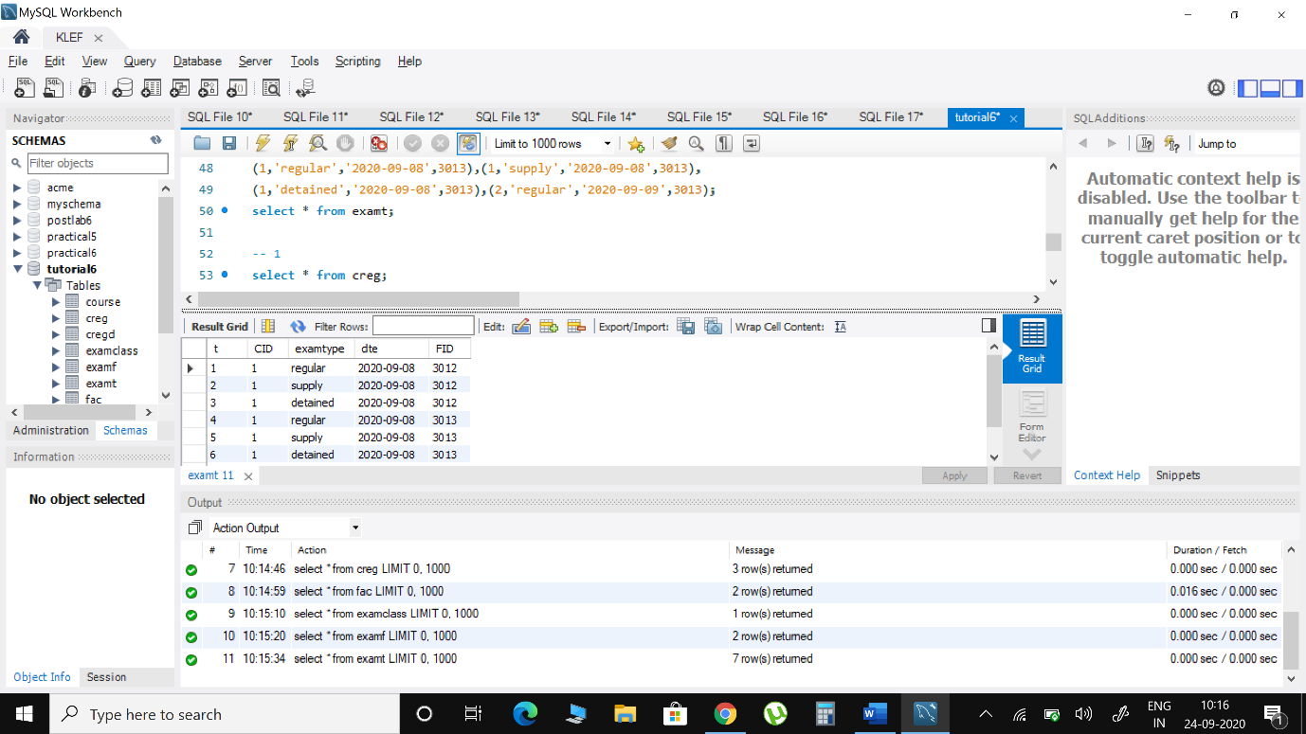

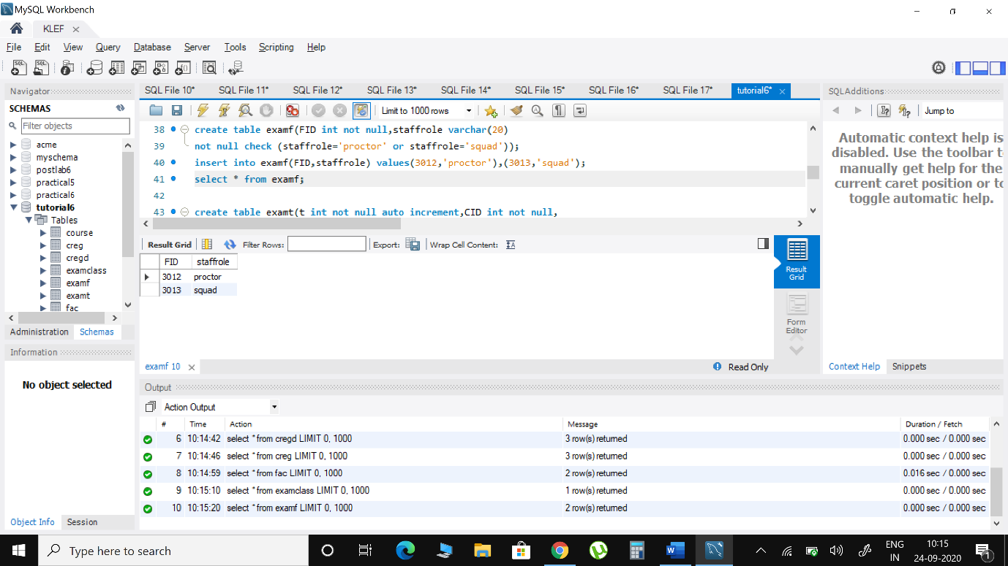

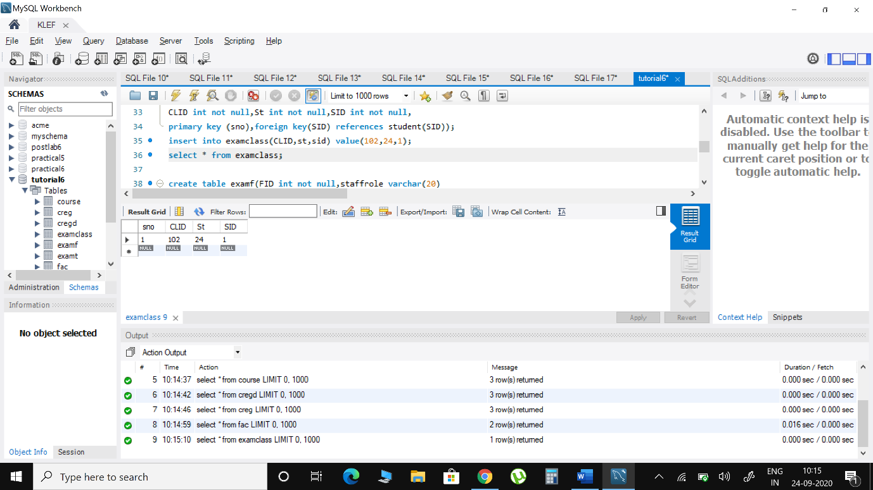

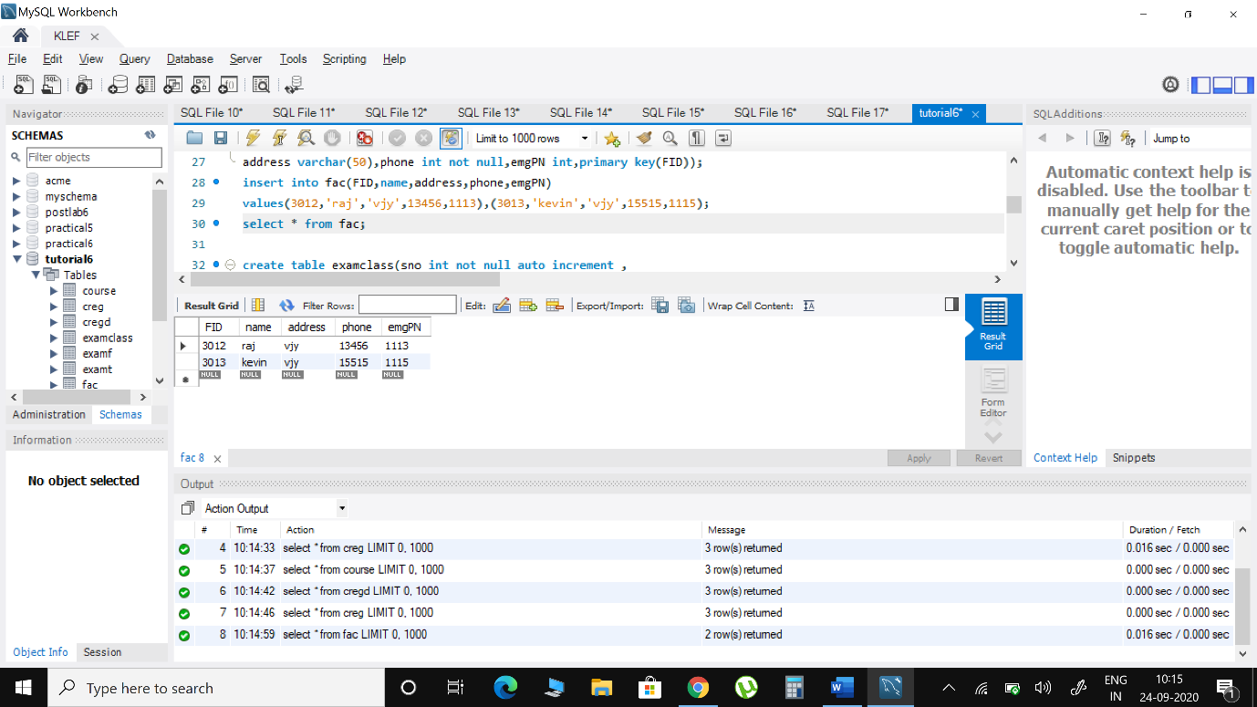

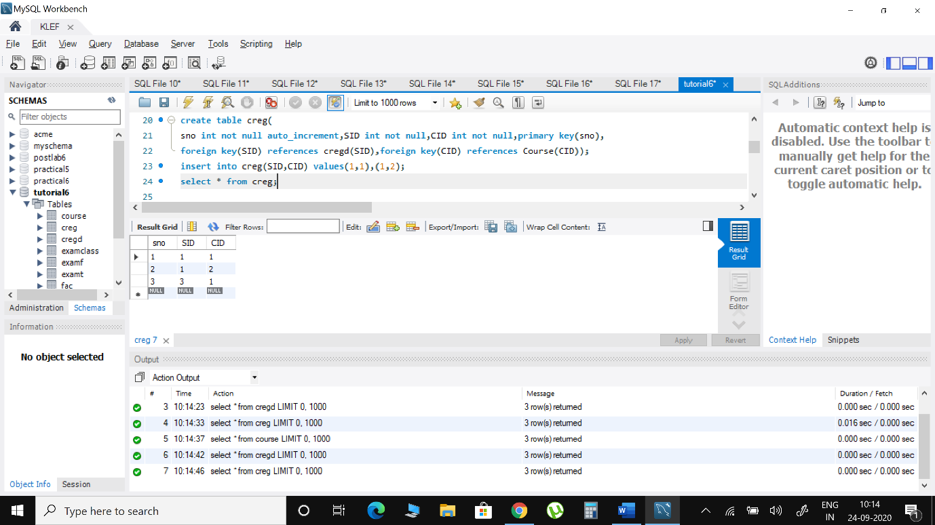

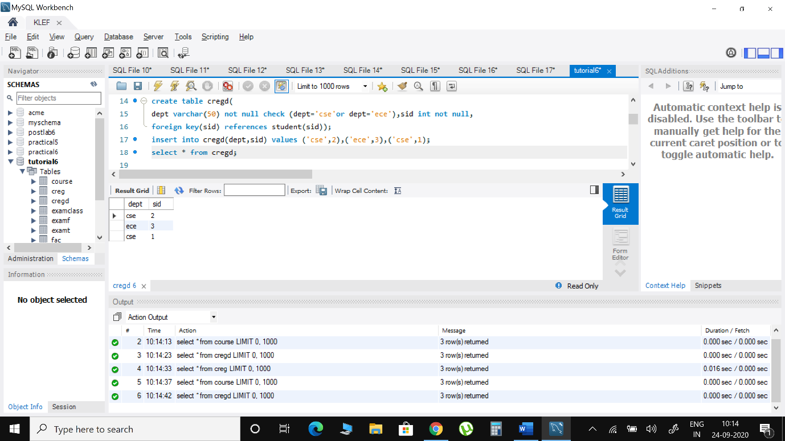

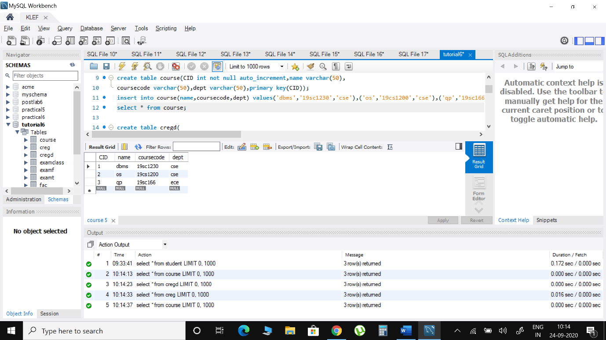

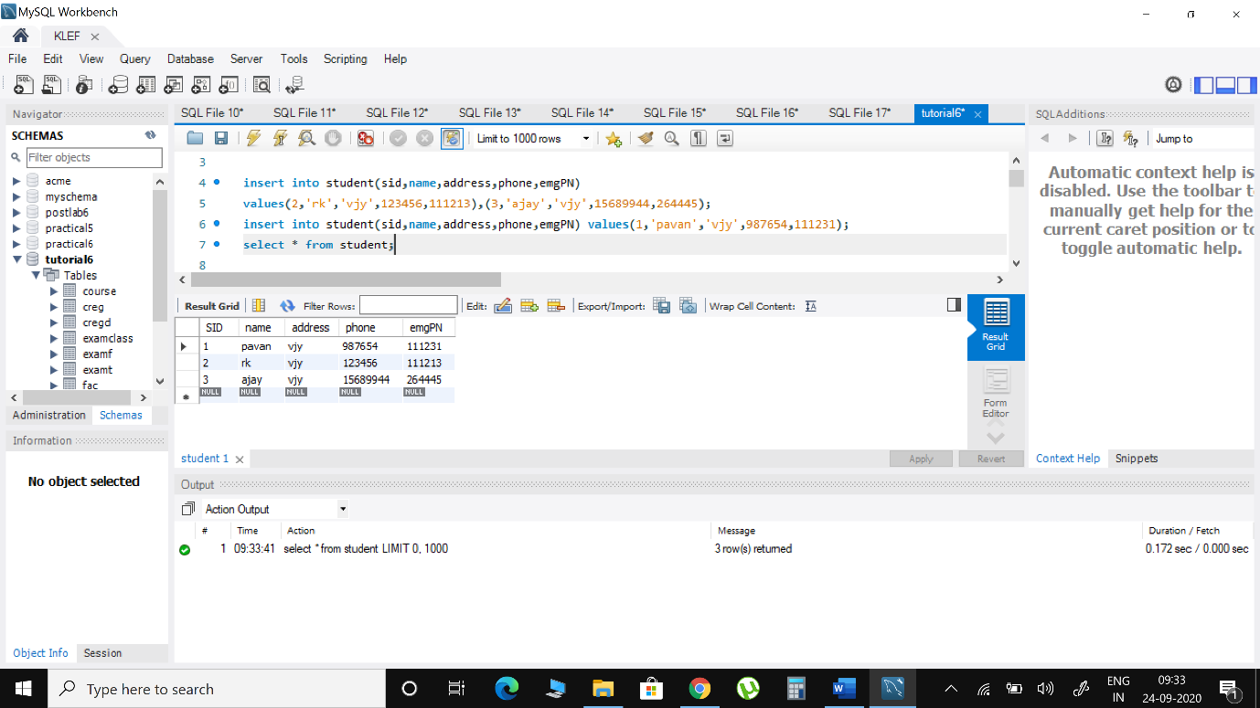

1. **Display the number of students enrolled for exam ‘DBMS’**

select count(*) as no_stud_dbms from creg where cid in (select cid from course where name='dbms');

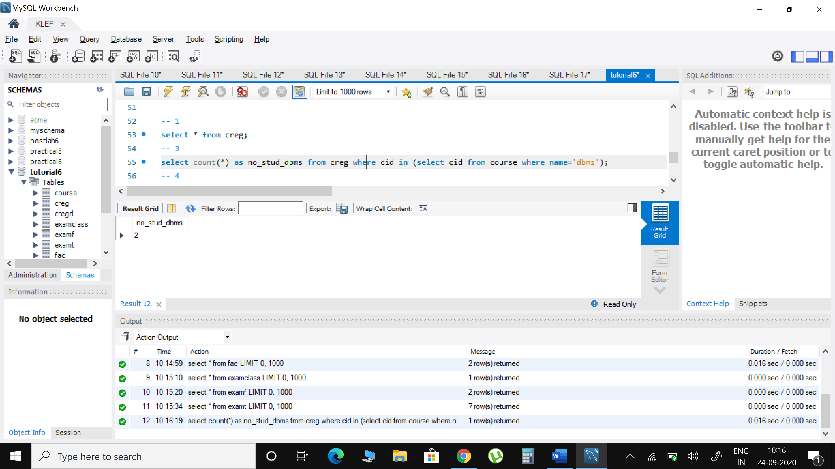

1. **Show the details of proctors having duty more than 3 times**

select * from fac where fid in (select fid from examt group by fid having count(*)>=3);

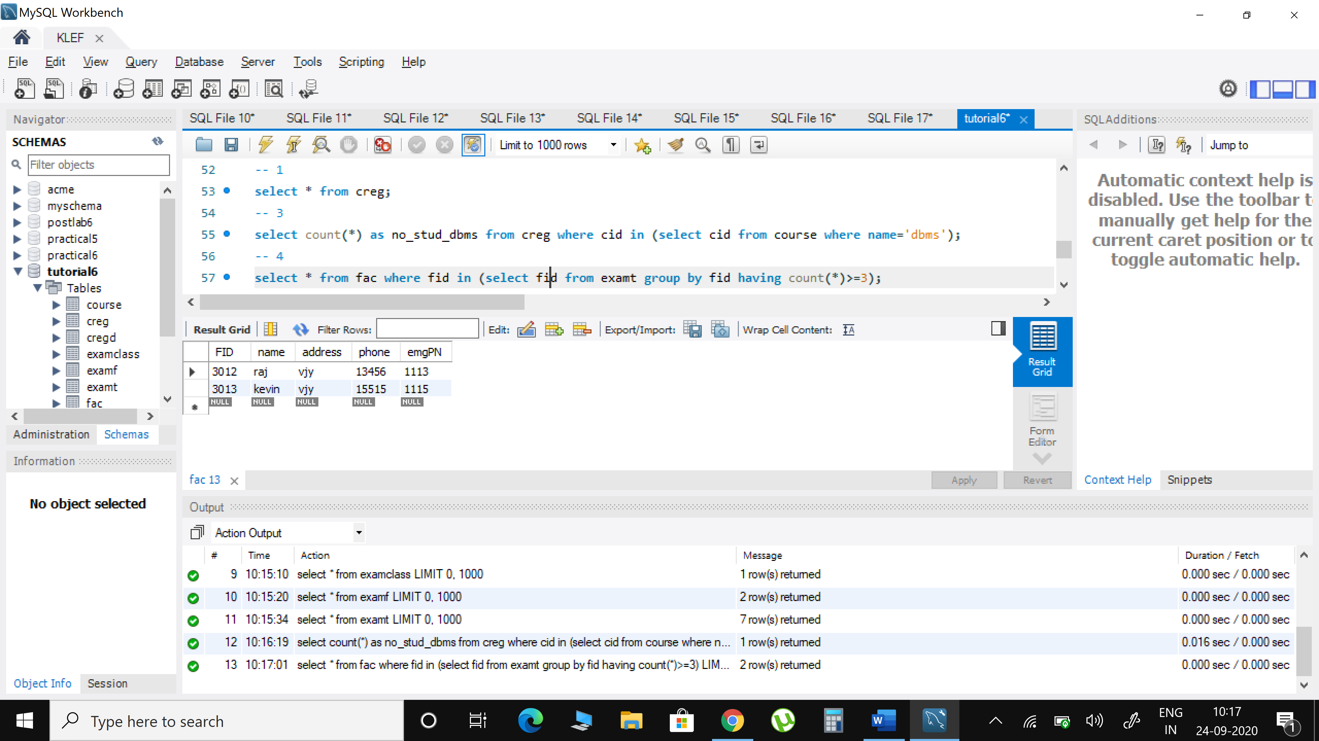

1. **Get the details of faculty working as squad**

select * from fac where fid in (select fid from examf where staffrole='squad');

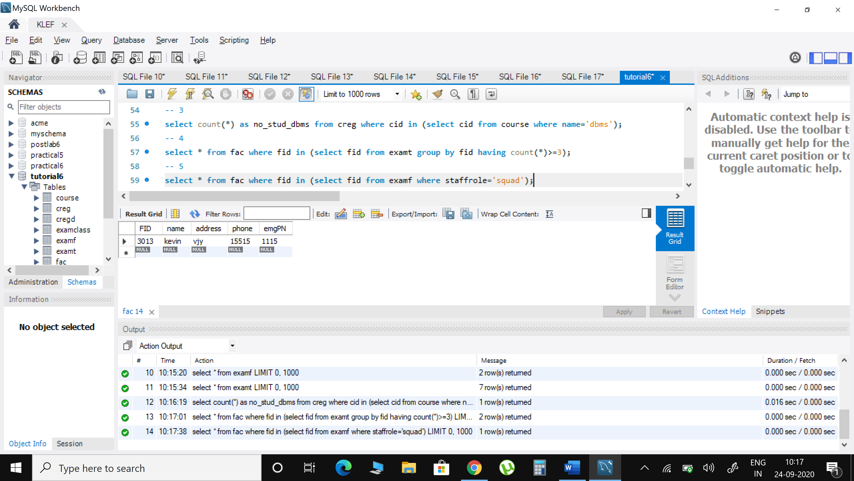

1. **Display the details of proctors and squad for exam ‘DBMS’**

select * from fac where fid in (select fid from examt where CID in (select cid from course where name='DBMS'));

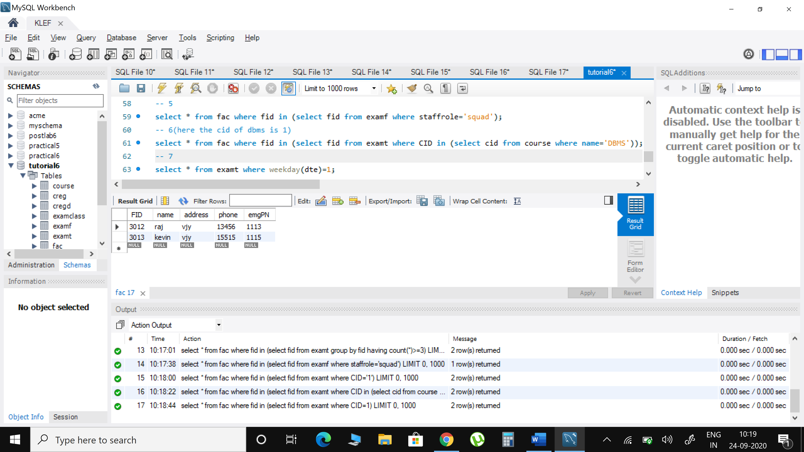

1. **Show the number of rooms allotted for each course on ‘Tuesday’**

select * from examt where weekday(dte)=1;

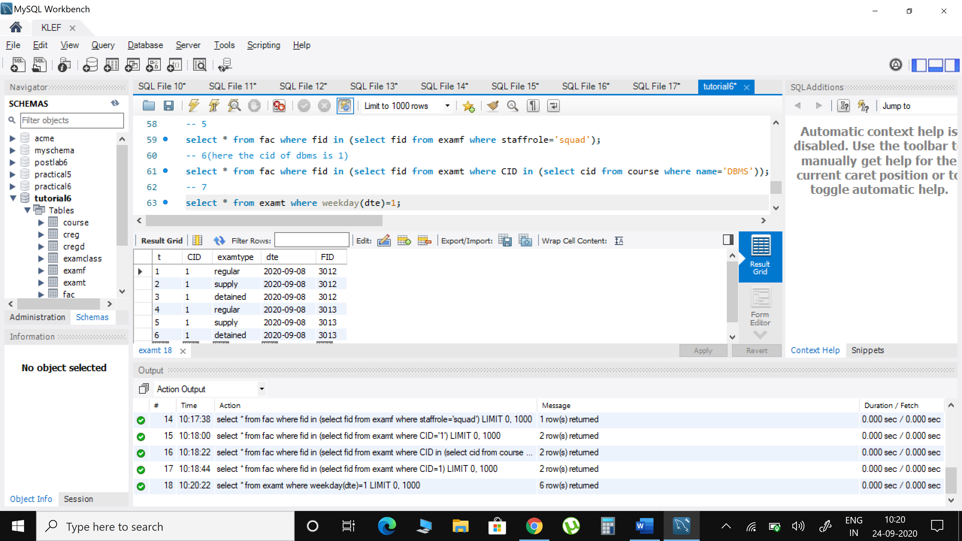

1. **Update the exam date of ‘OS’ which is postponed to 2 days after the scheduled date**

update examt set dte='2020-09-11' where cid=2 and t=7;

select * from examt where t=7;

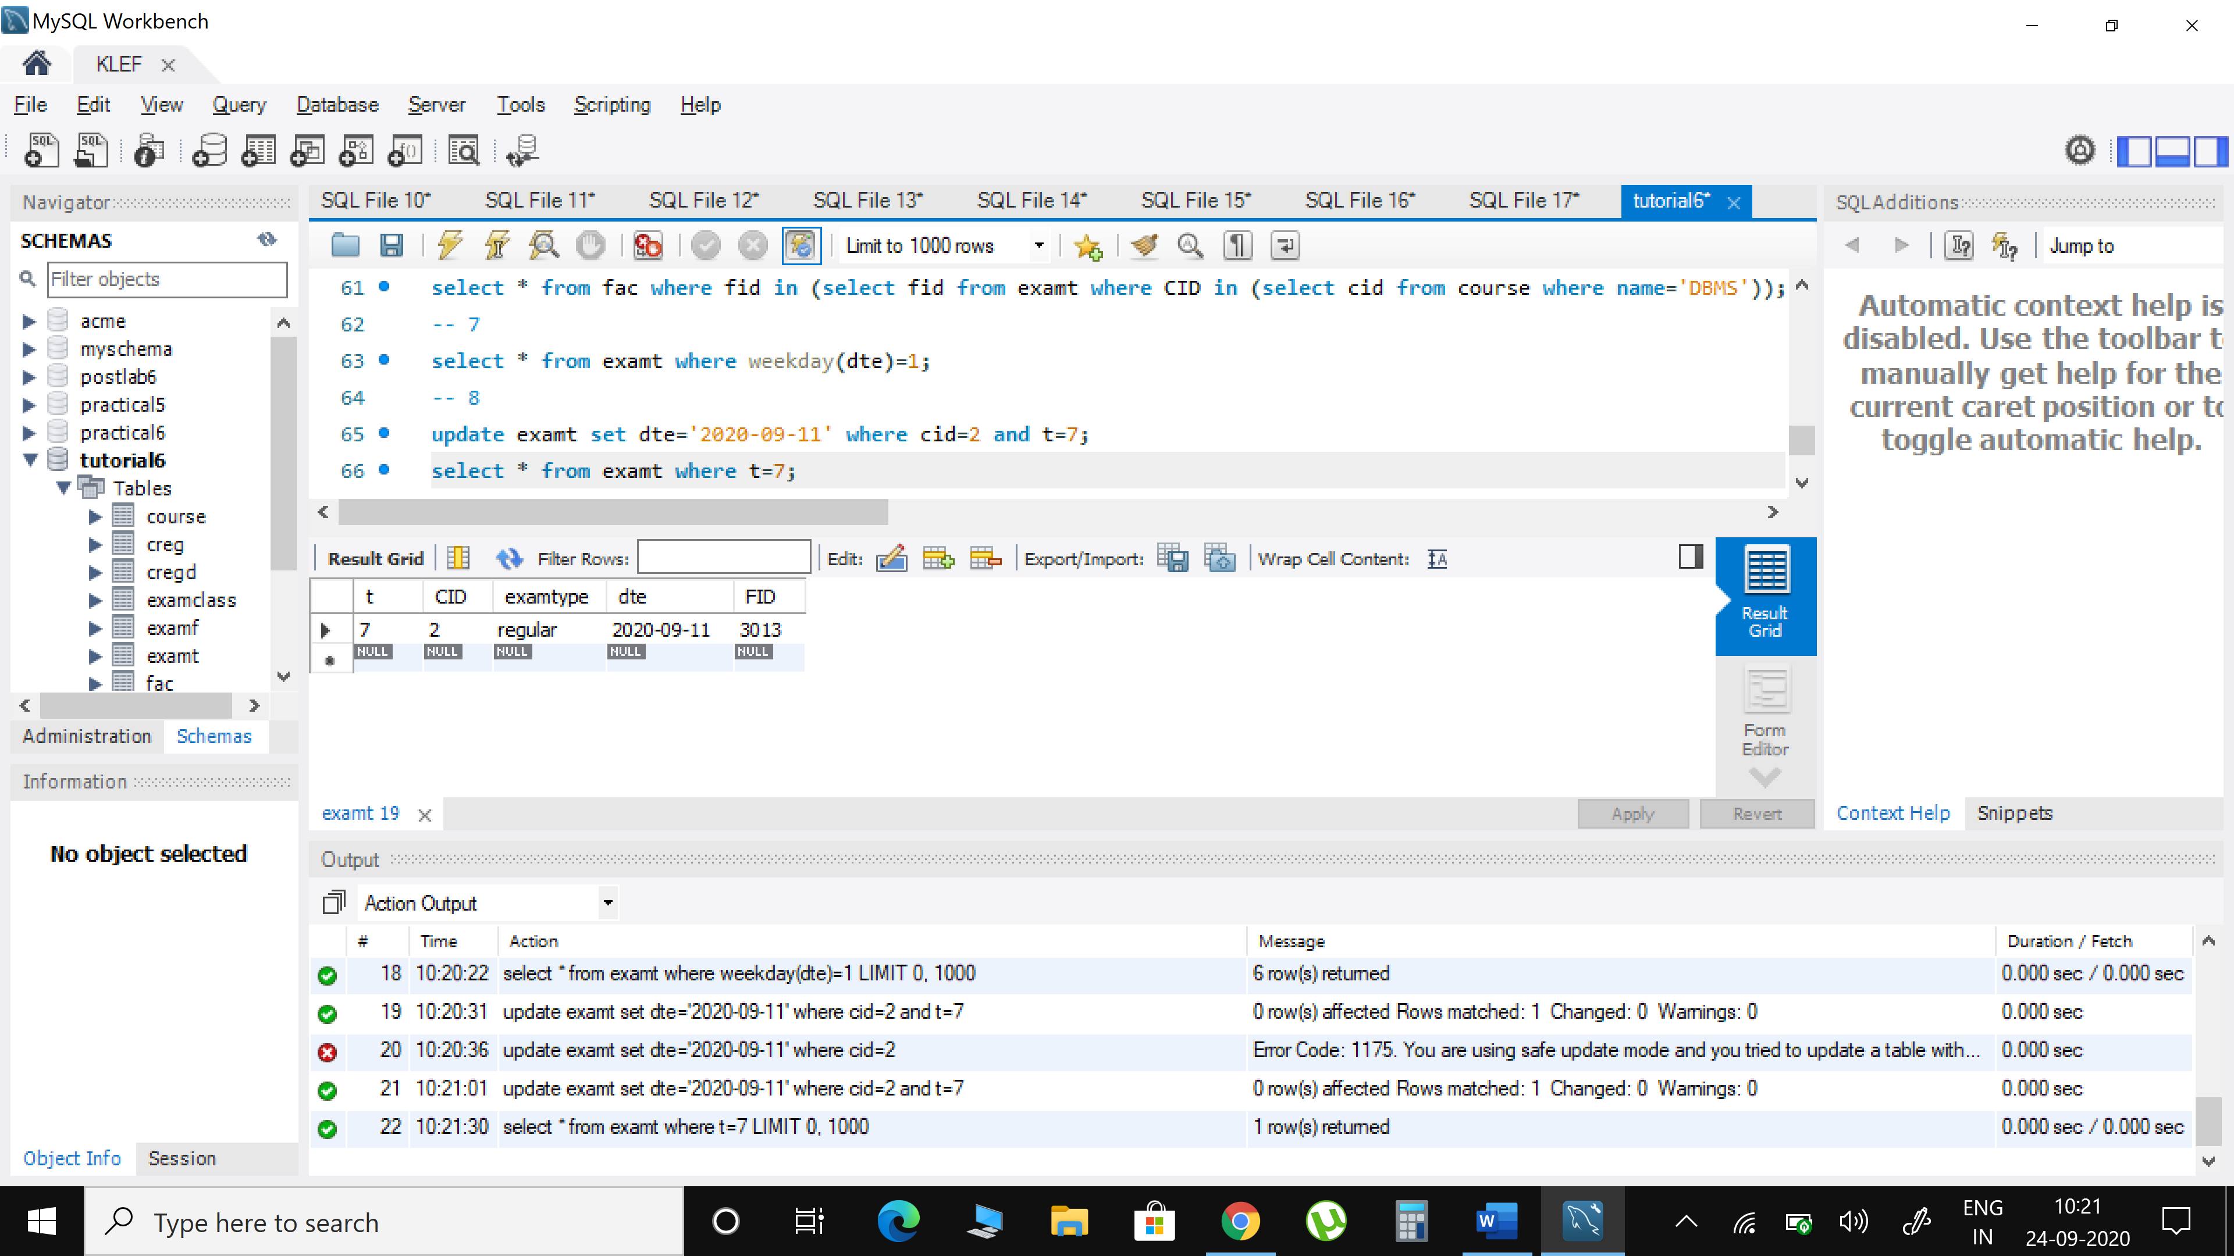

1. **Give the no. of students enrolled in each course department-wise**

select d.dept,course.name,count(*)as students_count from creg c inner join cregd d on c.SID=d.sid inner join course on c.cid=course.cid group by d.dept,c.cid;

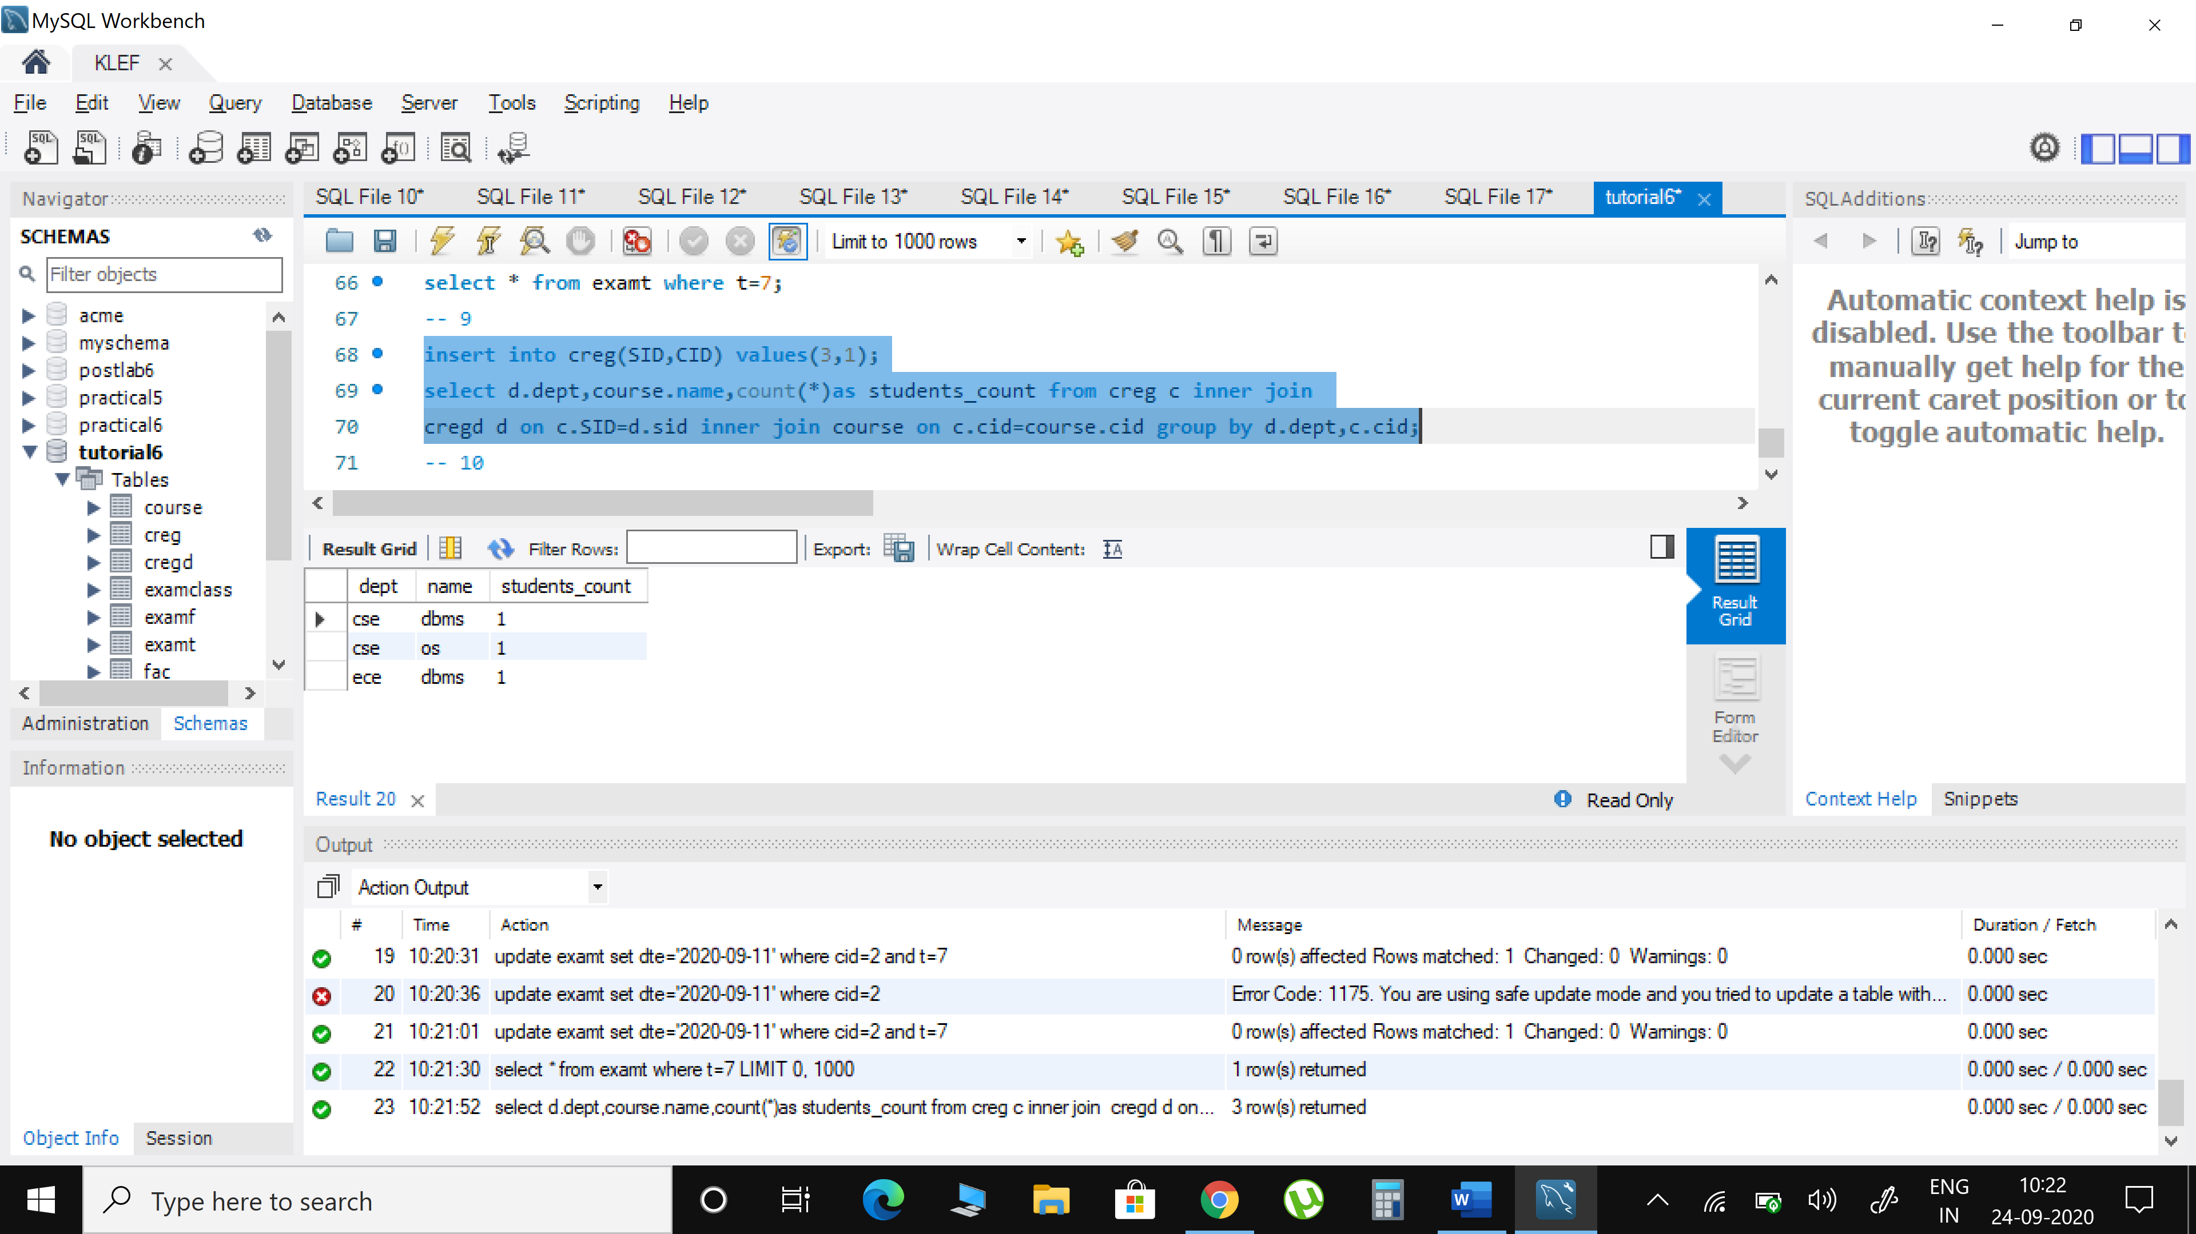

1. **Display the course details where the enrolled students are greater than the enrolled students in DBMS**

select * from creg group by cid having count(*) > (select count(*) from creg where cid in (select cid from course where name='DBMS'));

